Large-scale Estimates of Leaf Area Index from Active Remote Sensing Laser Altimetry

C. Mahoney1* & C. Hopkinson1

1Department of Geography, University of Lethbridge, Lethbridge, Alberta, T1K 3M4, Canada.

*Corresponding author. E-mail: craig.mahoney@uleth.ca

# Abstract

Models of canopy Leaf Area Index (LAI) can support the quantification of biomass and carbon stocks, as well as be used as input parameters into energy balance and hydro-meteorological process models. LAI is therefore a useful spatial variable that is used in guiding the planning and implementation of sustainable forest and water resource management strategies. Remote sensing has played a significant role in estimating and monitoring LAI via passive optical technologies over recent decades, however, due to canopy penetration constraints in dense forests, lower tier canopies and under-story foliage structure can be omitted. This study utilises an active laser altimeter (Geoscience Laser Altimeter System; GLAS) to retrieve LAI estimates at large scales, which are then integrated with other remote sensing products via the Random Forest algorithm to map LAI across Australia. Large-scale LAI estimates mapped at 250 m compared well with ALS data (R2=0.64, RMSE=1.10 m2m-2), whereas MODIS comparisons (1 km resolution) underperformed (R2=0.30, RMSE=1.78 m2m-2) with respect to a GLAS product computed at the same resolution (R2=0.61, RMSE=1.18 m2m-2). With the planned launch of other spaceborne altimeters (ICESat-2 and the Global Ecosystem Dynamics Investigation (GEDI) LiDAR) the current approach will serve in retrievals of LAI estimates in the future.

# Keywords

Forestry; LiDAR; Leaf Area Index; Random Forest

# Introduction

The spatial distribution of foliage within a forest canopy controls numerous relationships between the ground and atmosphere as well as those between the canopy and atmosphere, including, but not limited to: light and energy transfers (Traver et al. 2010){Traver, 2010 #350}, precipitation interception (Wilson et al. 2001), photosynthesis rates and magnitudes (Chasmer et al. 2008), evapotranspiration (Zhao et al. 2013), and aerosols. Consequently, parameters describing the spatial distribution of canopy and within canopy structures are necessary inputs to numerous ecological models employed to simulate mass and energy transfers within forest environments (Richardson et al. 2012).

Leaf Area Index (LAI), broadly defined as one half of the the total leaf surface area projected per unit ground surface area on a horizontal plane (units m2m-2) (Watson 1947, Richardson et al. 2009, Hopkinson et al. 2013), is an important biophysical parameter that describes canopy/foliage structure. Typically true LAI is measured via destructive sampling at local scales as non-destructive measurement is non-trival (Chen et al. 2006). As a result, effective LAI (LAIe) is more commonly measured in the field and often later calibrated to true LAI based on a variety of numerical modifiers (Chen et al. 2006). Whilst analogous to LAI, LAIe is incapable of isolating and distinguishing between wooded or leaf components, or accounting for variations in apparent leaf area due to leaf, branch, and shoot clumping effects (Chen et al. 2006, Ryu et al. 2012). In the field LAIe is often approximated based on the Beer-Lambert law, digital hemispherical photographs (DHP), the TRAC instrument, or commercially available canopy analysers (such as the LI-COR LAI-2000).

The most accurate estimates of LAI have typically been inferred from field acquired measurements which are time consuming, costly, and are often spatially limited due to logistical and in some cases remote access restrictions. Consequently, the derivation of LAI from active remote sensing technologies (such as Light Detection and Ranging; LiDAR) is an area of intense research due to: i) active sensor canopy penetration, ii) relative ease to acquire data for remote locations, and iii) the pursuit of large-scale retrievals with little time concern (relative to filed acquisitions). The use of airborne LiDAR (or airborne laser scanning; ALS) data for the modelling of LAI or LAIe from field measurements has been relatively well explored, but is still somewhat spatially limited in the context of country-wide and/or continental modelling applications. The large-scale development of such biophysical parameters requires the use of spaceborne sensors.

The Geoscience Laser Altimeter System (GLAS) on board the recently decommissioned Ice, Cloud, and land Elevation Satellite (ICESat) provided the only near global dataset of laser altimeter data for use in biosphere applications. However, the large footprint, waveform nature of the system has proved challenging in deriving canopy cover and LAI estimates due to the optics inability to account for within canopy energy loss via scattering, and/or the difference in reflectivity between the canopy and ground surfaces. The latter phenomena was initially noted in airborne waveform systems, such as: SLICER (Scanning LiDAR Imager of Canopies by Echo Recovery) and LVIS (Laser Vegetation Imaging Sensor) (Lefsky et al. 1999, Means et al. 1999, Tang et al. 2012).

Regardless of documented challenges, LAI retrievals from GLAS data have been pursued. First, found high correspondence (R2=0.84) between field measured and GLAS predicted values of LAI, however, the study was tuned by statistical models and validated across a relatively small sample of 15 field plot locations only, where the impact of any terrain was purposely removed. This methodology is unlikely to be applicable at large-scales, as it does not account for environmental variability and/or complexity. Second, Tang et al. (2014) built on previous work (Tang et al. 2012, Tang et al. 2014), implementing a recursive method to modify canopy and ground energy contributions estimated from Geometric Optical and Radiative Transfer (GORT) processed GLAS waveforms. The method accommodated canopy and ground reflectance differences modelled from an extensive array of field data, and relied on *a priori* knowledge of the maximum potential LAI, sourced from Moderate Resolution Imaging Spectroradiometer (MODIS) measurements. Whilst widely applicable, this methodology requires many inputs and is correlated with MODIS estimates of LAI which exhibit unquantified uncertainties with respect to field derived equivalents.

The current study aims to bridge between local- and large-scale derivations of LAI from GLAS via the development and execution of a more generalised methodological work flow that minimises the use of field data. Additionally, this study employs a robust validation dataset against which independent predictions of GLAS-based LAI will be compared and quantified. This work will make use of the research infrastructure offered by the Terrestrial Ecosystem Research Network (TERN), utilising coincident DHP and ALS datasets available across Australia.

# Study Region & Data

Six TERN sites that represent a cross-section of Australian forest ecosystems were chosen for model development purposes (Figure 1 and Table 1). Data available at each site included digital hemispherical photographs (DHPs) and coincident ALS data; an effort was made to ensure cross-site data acquisitions were made under similar conditions and instrument configurations.

A further 14 sites were available for assessment purposes with respect to regional LAI predictions (Figure 1 and Table 1). Of these additional sites, four exhibit coincident GLAS footprint data.

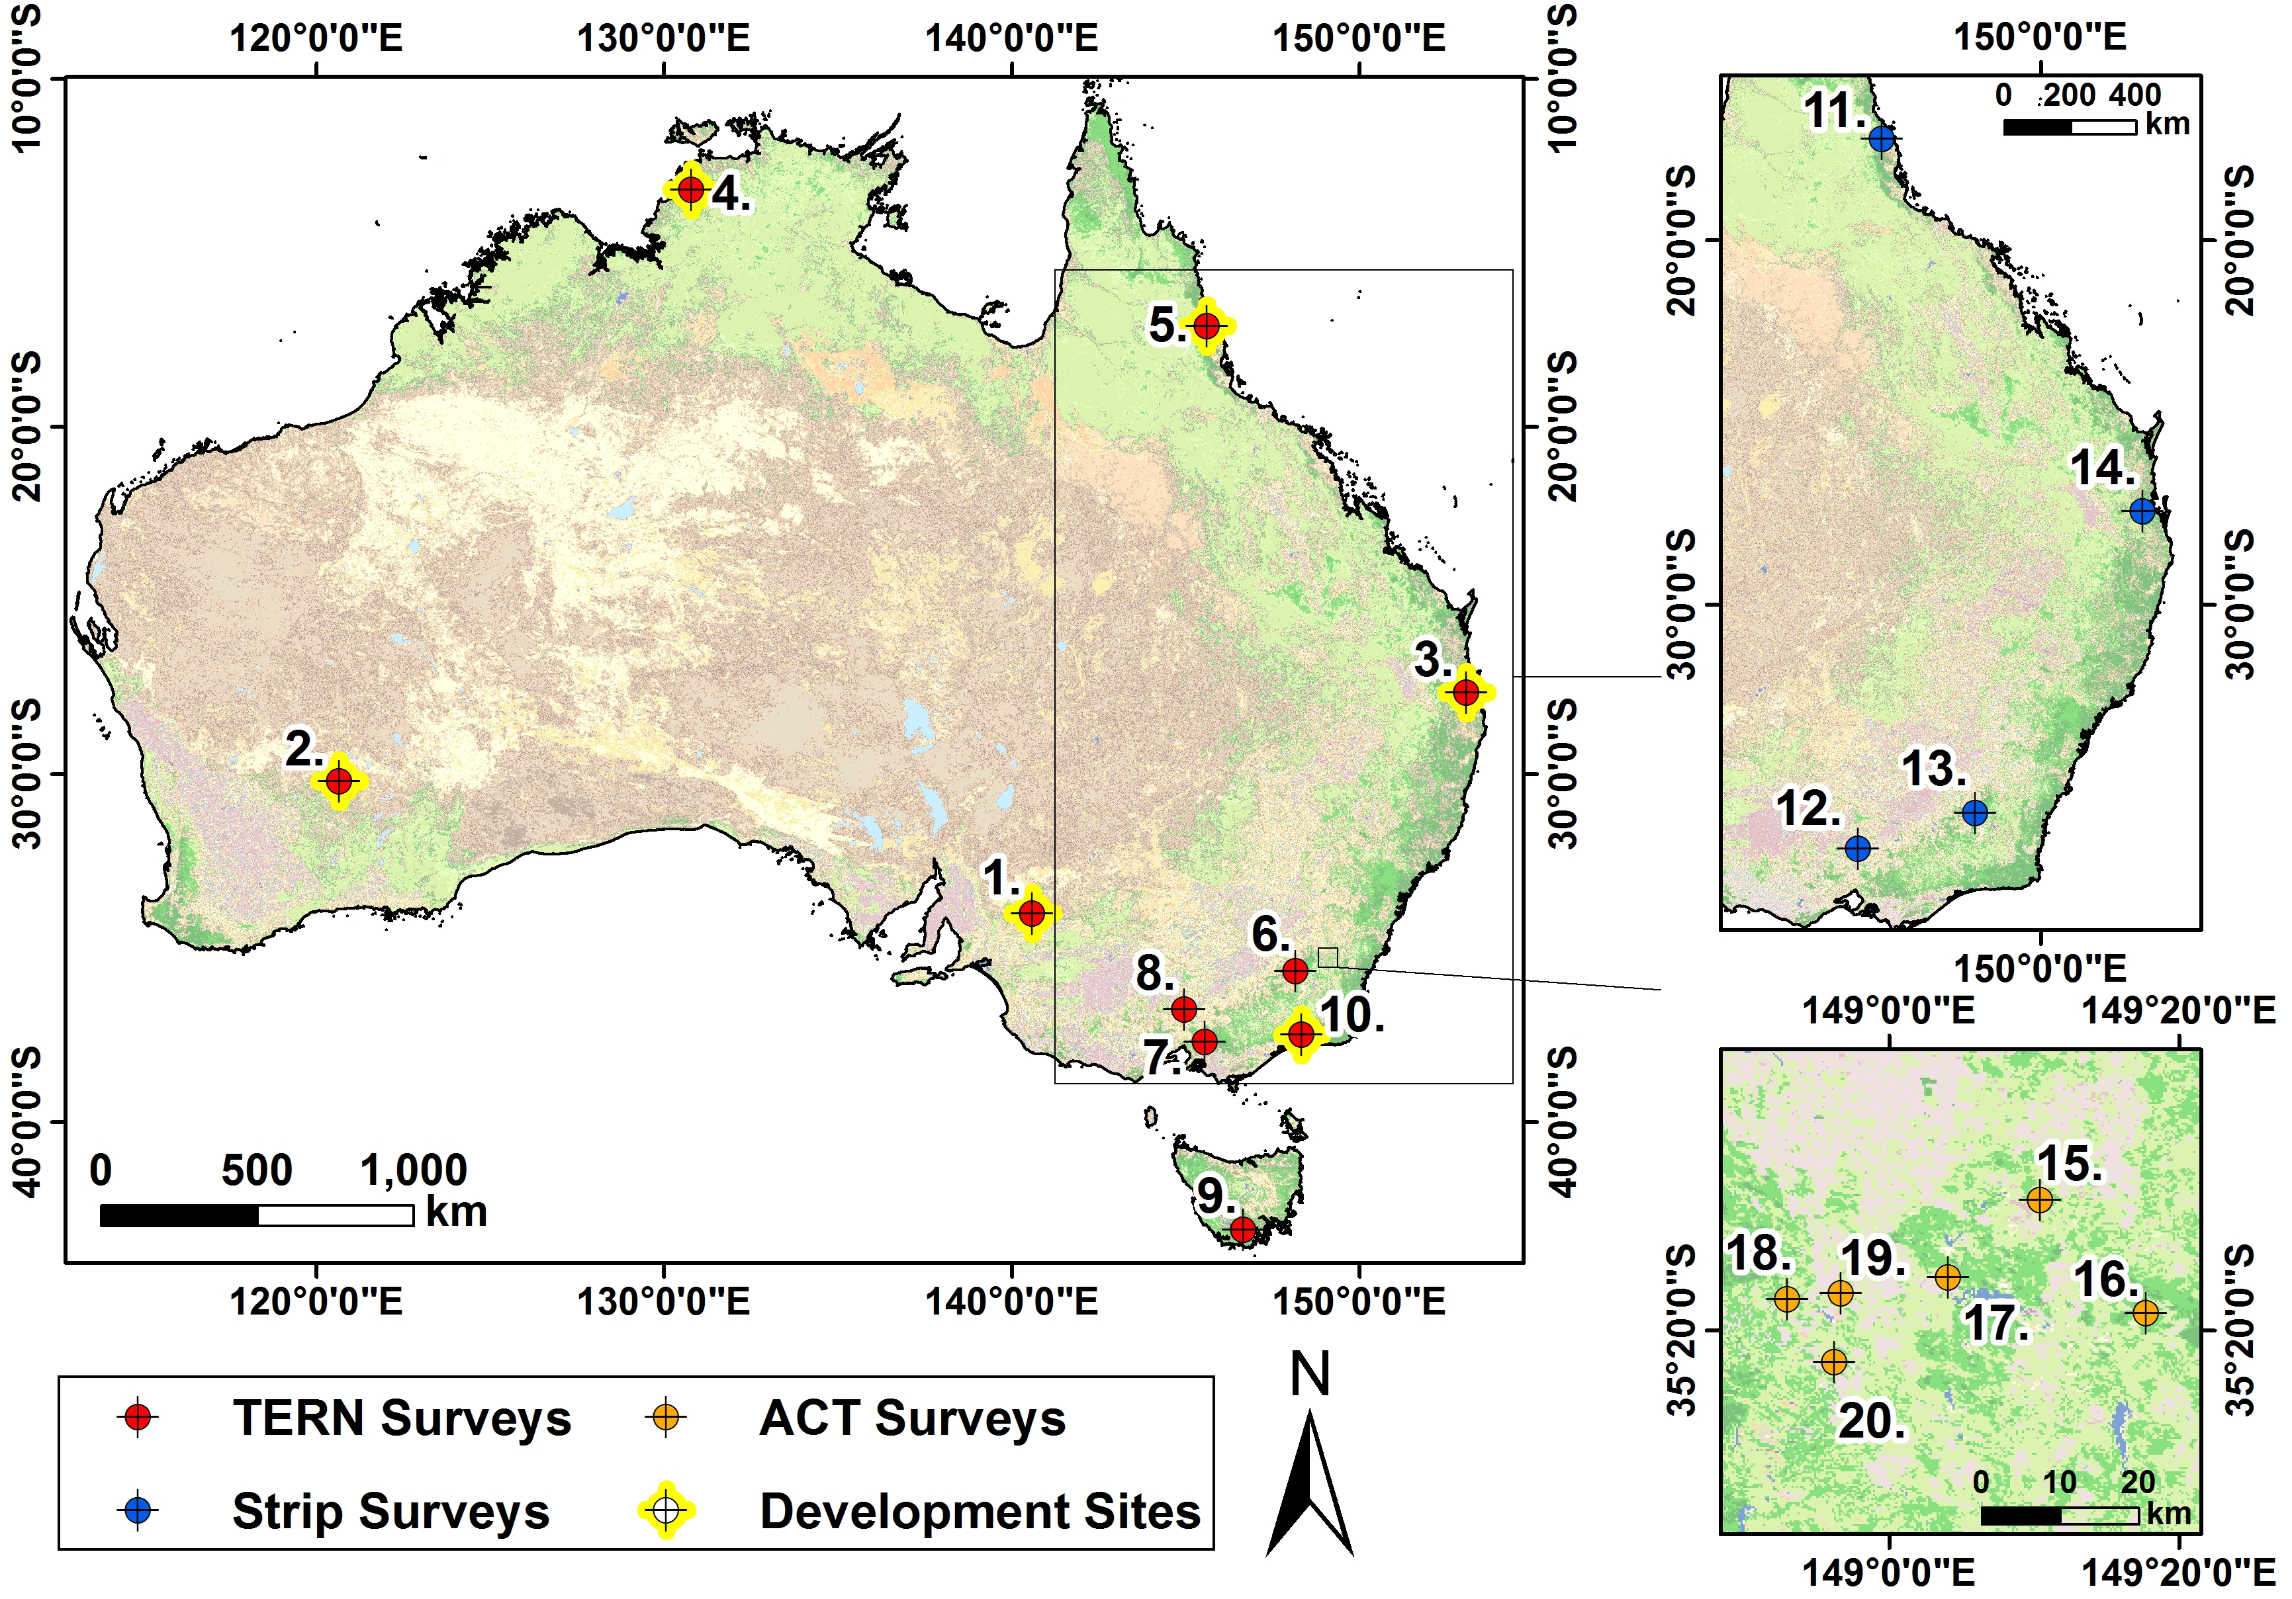

Figure Location of study sites employed throughout this study against an Australia specific land cover classified background sourced from the Dynamic Land Cover Dataset (circa 2012). Model development sites are indicated, remaining sites were used for model validation.

## Hemispherical Photography

Field plot-scale LAI data were obtained through DHP analysis. The protocol for acquiring DHP at within site plot locations was to acquire images during summertime diffuse light conditions without the presence of scattered or intermittent cloud cover, as the brightness of such bodies can artificially reduce leaf cover near leave edges (Trevithick 2015). Up to 13 images were captured at each location: one at the plot centre, six at a 25 m radius from the centre covering a 360° view at 60° azimuth intervals from north, and a further six at a 50 m radius along the same radial bearings. Each image was captured with its top orientated towards magnetic north, and at a height of approximately 1.3 m above the ground. A differential GPS measurement was taken at each plot centre from which the necessary bearing and distance was used to geolocate each radial image. At each location three photographs were captured in raw format: one at automatic exposure, one a single f-stop of under-exposure, and the final image under-exposed by two f-stops. For further information on DHP acquisition protocols see (Trevithick 2015).

It is important to note that the protocols described here were those followed in ideal conditions, negating time constraints and environmental obstructions (vegetation) where possible. However, the protocol was not always followed exactly and some images were not captured at certain sites. Some images had to be removed from analysis due to within-image sun and/or bright cloud exposure.

Table Summary of site characteristics and ALS data acquired at all sites employed in the current study.

|  |  |  |  |  |  |  |
| --- | --- | --- | --- | --- | --- | --- |
|  | **No./Site** | **Acquired** | **Instrument** | **PPM2** | **Characteristics** | **References** |
| TERN | 1. Chowilla | Feb/2012 | Reigl Q560 | 27 | Undulating, open riverine vegetation | (Meyer et al. 2015) |
| 2. Credo | May/2012 | 15 | Low relief; open temperate woodland | (Macfarlane et al. 2007, Watson et al. 2008) |
| 3. Karawatha | Oct/2013 | 19 | Flat parkland; low to medium density | (Bond and Jones 2008) |
| 4. Litchfield | Jun/2013 | 14 | Low relief; open savanna | (Finlayson and von Oertzen 1996) |
| 5. Robson Creek | Sep/2012 | 21 | Moderate relief; closed tropical rainforest | (OzFlux 2014) |
| 6. Tumbarumba | Sep/2012 | 14 | High relief; open to closed canopy | (van Gorsel et al. 2008, Hopkinson et al. 2013) |
| 7. Watts Creek | Apr/2012 | 17 | High relief; semi-open temperate forest | - |
| 8. Whroo | Apr/2012 | 15 | Low relief; semi-open woodland | - |
| 9. Warra | May/2014 | 25 | Moderate relief; closed temperate forest | (TERN 2013) |
| 10. Zigzag Creek | Apr/2012 | 13 | Moderate relief; open–closed forest (elevation dependent) | - |
| Strips | 11. Robson Strip | Sep/2012 | Reigl Q560 | 19 | Same as Robson Creek | - |
| 12. Rushworth | Apr/2012 | 17 | Same as Whroo | - |
| 13. Tumbarumba Strip | Nov/2009 | 14 | Same as Tumbarumba | (van Gorsel et al. 2008, Hopkinson et al. 2013) |
| 14. Walkabout Creek | Oct/2013 | 25 | High relief; closed forest | - |
| ACT | 15. ACT A1 | Dec/2013 | Leica ALS50-II | 13 | Sparse mixed vegetation | - |
| 16. ACT A2 | 13 | Moderate relief, some man-made stands | - |
| 17. ACT B | 6 | Low relief; semi-open forest | - |
| 18. ACT C1 | 6 | - | - |
| 19. ACT C2 | 5 | Moderate relief | - |
| 20. ACT C3 | 7 | - | - |

## Response Data

The GLAS land data (GLA14), release 33 (Brenner et al. 2003, Zwally et al. 2011) were employed to derive estimates of canopy gap fraction in this study; this derivation served as the response variable in predictive models.

GLAS was operational from 2003 to 2009 and acquired data in distinct, approximately 1 month periods, defined as laser campaigns; between 2-3 campaigns were acquired annualy (Harding and Carabajal 2005, Schutz et al. 2005). One of three available lasers was fired in isolation to acquire data for a given campagn. Campaigns were named after which laser was fired and how many times; for example, campaign L3D denotes the fourth time laser 3 was fired. The area illuminated upon the Earth’s surface by each footprint varied by campaign, eariler campagns (L1-L2C) were more elliptical whereas later campaigns were circular (Abshire et al. 2005).

Each laser fired a Gaussian shaped pulse exhibiting a full width at half maximum (FWHM) between approximately 0.70 and 0.90 m wide (5-6 ns time equivalent) in the 532 nm and 1064 nm wavebands (Mahoney et al. 2016). The reflected (or return) pulse was recorded near the surface for a range window of either 81.6 m (544 ns) or 150 m (1000 ns) for earlier and later campaigns, respectively. The returned pulse was recorded at 0.15 m (0.5 ns) intervals and digitized to a waveform. The peaks and troughs in the returned waveform represent terrestrial surfaces intercepted by the laser pulse whilst in transit. Following the method of Duong et al. (2008), up to six Gaussians were fitted to each waveform, the sum of which defines the ‘model alternate fit’ return pulse; this signal is utilized for GLAS analysis throughout this study.

It is important to acknowledge the challenge of working with GLAS waveforms that do not exhibit distinct peaks from a single surface. For example, laser energy can be reflected simultaneously by vegetation and ground surfaces in the presence of slope. This can cause signal mixing as returns are sourced from multiple surfaces occuring at similar elevations (Chen 2010, Mahoney et al. 2014). Waveforms exhibiting such features are challenging to interpret and can often lead to the dervation of spurious estimates of vegetation parameters (Rosette et al. 2010, Rosette et al. 2013).

## Predictor Data

A total of 13 different supplementary ‘predictor’ variables were employed for use in predictive models. Predictor variables (or predictors) are coincident with, and ideally exhibit some correspondence with the response variable. Predictors employed here (Table 2) were derived from Shuttle Radar Topology Mission (SRTM) and MODIS data; additional products were from the Australian Soil Resource Information System (ASRIS), and the AusCover remote sensing data facility of TERN. Predictors were numerical or thematic classes and where scaled to a 250 m grid; the smallest common spatial resolution among all predictors (MODIS products).

Predictor selection was based on their ability to represent the growth, and/or spatial distribution of vegetation within the landscape. Although climate data are not explicitly represented within predictors due to resolution constraints, the National Vegetation Information System (NVIS) predictor exhibits embedded climate information with respect to ecosystem composition.

Table Summary of predictors used in predictive models for producing an Australia-wide LAI product.

|  |  |  |  |
| --- | --- | --- | --- |
| **Data** | **Units** | **Description** | **References** |
| Aspect |  | Derived from SRTM. Aspect is the direction of the maximum rate of change in the z-value from each cell in a raster surface | (Burrough 1986) |
| Slope |  | Derived from SRTM. Slope is the rate of maximum change in z-value from each cell | (Burrough 1986) |
| Elevation | m | National 1 second (30 m) Shuttle Radar Topography Mission (SRTM) Digital Elevation Model (DEM), Version 1.0 | (Gallant et al. 2011) |
| Valley bottom flatness (VBF) | - | VBF identifies areas of deposited material at a range of scales dependent on the fact that valley bottoms are low, flat regions relative to their surroundings | (Gallant and Dowling 2003) |
| Vegetation continuous fields (VCF) | % | The VCF collection contains proportional estimates for vegetative cover types: woody vegetation, herbaceous vegetation, and bare ground | (DiMiceli et al. 2011) |
| Vegetation classification | - | National Vegetation Information System (NVIS): provides vegetation type, distribution, and extent information across Australian landscapes | (ESCAVI 2003) |
| Vegetation height | m | Canopy height sourced from the integration of GLAS footprints and Australian inventory data | (Mahoney et al. 2016) |
| Land cover | - | Dynamic Land Cover (DLCD) Dataset of Australia: nationally consistent thematic land cover map | (Lymburner et al. 2011) |
| Soil type | - | Atlas of Australian Soils: provides a consistent national description of Australia’s soils | (ASRIS 2014) |
| Soil depth | m | Depth of soil profile (A and B horizons) | (Rossel et al. 2015) |
| Soil nitrogen | % | Mass fraction of soil based nitrogen by weight |
| Soil phosphorus | % | Mass fraction of soil based phosphorus by weight |
| Soil PH | - | PH of 1:5 soil/0.01M calcium chloride (CaCl2) extract |

## Validation Data

Regional LAI predictions were assessed via ALS data from a total of 14 independent ALS sites (i.e. not utilised in model development; Figure 1). All ALS datasets were retrieved as multiple discrete return point clouds; although some sites have waveform data available, point cloud analysis was favoured for inter-site consistency.

Four TERN supersites measuring 5 km x 5 km, four variable size strips near some TERN supersites, and six irregularly sized Australian Capital Territory (ACT) sites were available for regional prediction assessment; site and ALS acquisition characteristics are detailed in Table 1.

# Methodology

## Hemispherical Photograph Analysis

All remaining post-filtered images were subject to the same analysis procedure in order to obtain estimates of LAI, where maintaining consistency was a primary focus. As a result, images at unique locations were subject to different f-stop values throughout analysis depending on lighting and environmental (vegetation density) conditions. The f-stops of images captured at all photo stations at a unique location, however, were kept constant to ensure analytical consistency.

Each of the photographs (post quality controlled) were analysed via the CIMES-fisheye package (Gonsamo et al. 2011). The analysis of images via this package requires that they be binary masked (classified in to 2 groups: sky and vegetation in this case) prior to processing. A threshold was applied to the blue band of the raw image only, due to more distinct sky and vegetation reflectance differences (Leblanc 2004). In this case the ImageJ open source image processing package (Schneider et al. 2012) was employed to create a binary masked image; selected primarily because of its numerous built-in auto threshold methodologies. Such automatic thresholding methodologies are favoured as multiple images were analysed per location; where manual threshold adjustment may introduce user-specific subjective inconsistencies between images, auto thresholding methods provide greater consistency.

All available ImageJ auto thresholding methods were trialed per site (not within-site locations, as little variation in vegetation characteristics is observed within each site), the method deemed to produce the best binary mask (based on visual inspection) was then applied to all images across that site. The final thresholding methodology applied across each site is noted in Table 3.

After binary images were produced, each image was processed through CIMES in two parts: the first to obtain canopy gap information, where the second makes use of these results to compute LAI. The first part of analysis scans the pixel map of the image from its centre to circumference (i.e. zenith to horizon). Then, starting north and rotating westward about the image centre (azimuth angle), derives information (gap or non-gap) for each sky segment in a step-wise fashion for each zenith (θ) and azimuth (ψ) angle. In this case, DHP derived gap fraction (P0) is defined by Equation 1.

 (1)

Where Pc is the portion of the image deemed to be canopy dominated pixels, and Ps is the image portion of sky dominated pixels. Generalisations are made to support P0 as a function of mean zenith and azimuth angles (varies as a function of zenith and azimuth step sizes). Therefore,by this method, P0 represents the relative proportion of open sky contained in any defined region on the image (Frazer et al. 1997). Given an estimate of P0, LAI was derived by the method of Campbell and Norman (1989).

This method assigns leaf angles by the ellipsoidal distribution function (Campbell 1986, Campbell and Norman 1989, Campbell 1990, Welles and Norman 1991, Thomas and Winner 2000). This assumes that the within canopy leaf angles are distributed at normal angles to small area elements on an ellpsoidal surface. This function encompasses information that approximates the shape of the crown (i.e. spherical, or horizonatally or vertically ellipsoidal). The ellipsoidal distribution function allows the derivation of the ellipsoidal extinction coefficient (Ke) as a function of the ellipsoidal parameter (x) and the normalized ellipse area (Λ), as per Equation 2.

 (2)

Gap fractions from Equation 1 are inverted to determine the best fit with incident θ via a constrained non-linear least squares regression in order to obtain values of x and L (LAI) to minimise the function (F) expressed in Equation 3 (where x > 0).

 (3)

The minimum can be determined by simultaneously solving ∂F/∂L=0, and ∂F/∂x=0. This allows x to be found by the bisection method, and L to be determined by substitution of Equation 2 in Equation 3.

In order to maximise consistency between DHP derivations and ALS models of P0 and LAI, two considerations were made. First, ‘overall’ computations of such parameters were considered from DHP. That is, L was calculated in the same way but *after* gap azimuthal (linear) averaging. In doing this the azimuthal heterogeneity gap distribution is averaged out, thus aligning the foliage elements to a random distribution model i.e. assuming the canopy is horizontally homogeneous. Overall values are useful for comparison with data obtained from above canopy, larger-scale sources such as aircraft. Second, of the nine ten degree wide annulus rings the DHP were decomposed in to, only the central four rings were considered in P0 and LAI calculations thus minimising the contribution of lower canopy elements which may appear less pronounced in ALS point clouds.

## ALS Leaf Area Index

LAI estimates derived from ALS and GLAS data were made as a function of ALS and GLAS GF. The processes involved in relating GF and LAI for both ALS and GLAS data are described here.

The simple ratio of returns method is employed to determine GF from ALS point cloud data (GFALS) (Hopkinson and Chasmer 2009). That is, GFALS is calculated as one minus the ratio of the sum of all returns (first, intermediate, and last) from 2 m above the ground (RElevation>2m) to the canopy top, and the number of all returns between the ground and canopy top (RAll; Equation 4).

 (4)

In this case, estimates of GF were determined from ALS data that were directly within the boundaries of unique DHP footprints as if they were projected on the ground with an 11.3 m radius from the photograph’s centre. A radius of 11.3 m was selected in order to restrict the ALS point cloud to within the spatial domain of the 4 central annulus rings of each DHP. This method allows a direct comparison between DHP and ALS results.

Table Summary of acquired images and associated image adjustment threshold method applied to each site from within ImageJ as a function of each site. Note: φ is latitude, λ is longitude, and N is the number of images acquired.

|  |  |  |  |  |  |  |  |
| --- | --- | --- | --- | --- | --- | --- | --- |
| **Site** | **ID** | **Acquired** | **φ[°]** | **λ[°]** | **N** | **Method** | **Reference** |
| Chowilla | Chow01 | 2012/01/30 | -34.002 | 140.587 | 7 | IsoData | (Ridler and Calvard 1978) |
| Chow02 | 2012/01/30 | -34.003 | 140.589 | 7 |
| Chow04 | 2012/02/01 | -34.003 | 140.579 | 12 |
| Chow05 | 2012/02/01 | -34.003 | 140.575 | 12 |
| Chow06 | 2012/02/02 | -34.003 | 140.567 | 13 |
| Credo | Credo01 | 2012/05/12 | -30.186 | 120.670 | 13 | IsoData | (Ridler and Calvard 1978) |
| Credo02 | 2012/05/15 | -30.191 | 120.656 | 8 |
| Credo03 | 2012/05/31 | -30.192 | 120.651 | 8 |
| Karawatha | Kara01 | 2013/02/04 | -27.625 | 153.089 | 13 | Intermodes | (Prewitt and Mendelsohn 1966) |
| Kara02 | 2013/02/05 | -27.625 | 153.087 | 12 |
| Kara03 | 2013/02/06 | -27.636 | 153.094 | 13 |
| Kara04 | 2013/02/06 | -27.643 | 153.074 | 13 |
| Litchfield | Litch02 | 2013/05/30 | -13.179 | 130.794 | 4 | Huang | (Huang and Wang 1995) |
| Litch04 | 2013/05/28 | -13.170 | 130.777 | 13 |
| Litch05 | 2013/05/28 | -13.158 | 130.778 | 13 |
| Litch06 | 2013/05/27 | -13.195 | 130.785 | 13 |
| Litch07 | 2013/05/29 | -13.192 | 130.800 | 13 |
| Litch09 | 2013/05/29 | -13.889 | 130.807 | 13 |
| Robson Creek | RCreek01 | 2012/09/14 | -17.105 | 145.615 | 4 | Moments | (Tsai 1985) |
| RCreek02 | 2012/09/14 | -17.105 | 145.613 | 4 |
| RCreek03 | 2012/09/15 | -17.106 | 145.616 | 5 |
| RCreek04 | 2012/09/15 | -17.102 | 145.611 | 2 |
| RCreek05 | 2012/09/15 | -17.099 | 145.609 | 4 |
| RCreek06 | 2012/09/15 | -17.094 | 145.610 | 3 |
| RCreek07 | 2012/09/15 | -17.094 | 145.611 | 4 |
| RCreek08 | 2012/09/15 | -17.095 | 145.619 | 5 |
| RCreek09 | 2012/09/15 | -17.092 | 145.619 | 4 |
| RCreek10 | 2012/09/15 | -17.118 | 145.607 | 4 |
| RCreek11 | 2012/09/15 | -17.118 | 145.603 | 3 |
| RCreek12 | 2012/09/15 | -17.117 | 145.603 | 5 |
| Robson01 | 2012/09/10 | -17.121 | 145.630 | 13 |
| Robson02 | 2012/09/12 | -17.118 | 145.633 | 13 |
| Robson03 | 2012/09/12 | -17.119 | 145.632 | 13 |
| Robson04 | 2012/09/14 | -17.110 | 145.603 | 12 |
| Zigzag Creek | Zigzag01 | 2012/04/18 | -37.460 | 148.342 | 12 | Moments | (Tsai 1985) |
| Zigzag03 | 2012/04/17 | -37.469 | 148.351 | 13 |
| Zigzag05 | 2012/04/19 | -37.472 | 148.336 | 13 |
| Zigzag06 | 2012/04/17 | -37.477 | 148.353 | 11 |

Once derivations of GFALS were obtained, a relationship to DHP derived LAI (LAIDHP) was established via a simple exponent model fitted by non-linear least squares (Equation 5; where a and b are model coefficients). This was established using data from the 6 sites that exhibit DHP, amounting to a total of 347 individual data points for model development.

 (5)

The 6 ALS sites employed in LAI model development varied in ecosystem composition and vegetation, and terrain characteristics. As a result it was assumed that such a cross-section of Australian ecosystems sufficiently represents all ecosystems within the country, thus permitting Equation 5 to be applied to GFALS values retrieved across all 20 ALS sites allowing the retrieval of ALS LAI.

## GLAS Leaf Area Index

The derivation of GLAS GF (GFGLAS) from waveform data is analogous to GFALS with minor modification. In place of a simple return count (R) ratio, the ratio of summed energy returns (ε) from ground and vegetation surfaces are utilized. That is, GFGLAS is calculated as one minus the ratio of summed return energy reflected from 2 m above the ground to the canopy top, and the energy sum between the ground and canopy top (Figure 2a; Equation 6).

 (6)

It is often challenging to locate the true ground elevation in GLAS footprints due to the presence of complex terrain or slope (Mahoney et al. 2014). Therefore, in order to minimize this effect the method of Rosette et al. (2008) is employed to determine GLAS footprint ‘ground’ elevations. This method screens the two least elevated of the (up to) 6 fitted Gaussians from each waveform and defines the ground elevation as the centre of which of the two Gaussians that exhibit the greatest amplitude (Figure 2b).

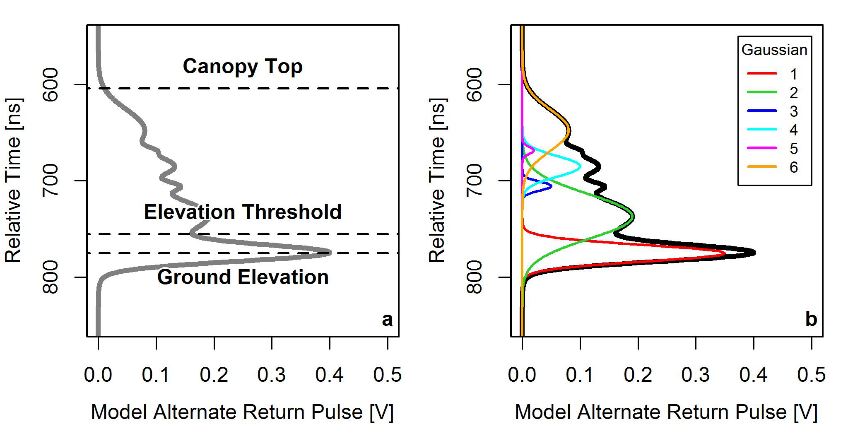

Figure Conceptualization of returned waveforms and the realtionship a) with canopy structure thresholds, and b) to the model alternate return pulse..

Additionally, literature suggests that waveform estimates of GF require scaling in order to account for the differences in reflectance properties between the ground and vegetation surfaces (Means et al. 1999, Lefsky et al. 2002). The current study addresses this via the method of Mahoney et al. (2017). By this method refined GLAS GF (GFR) can be defined as a function of observed energy contributions from ground and canopy elements, accommodating a scaling factor (n), and related to ALS derivations of GF (Equation 7). ALS estimates of GF were taken as ‘truth’, based on typically high corelation with field measured GF or variations such as cover fraction (Hopkinson and Chasmer 2009, Korhonen et al. 2011).

 (7)

Given the desired equivalence of ALS and GLAS estimates of GF, GFR in Equation 7 can be replaced with GFALS and rearranged to determine n (Equation 8). This allows for the refinement of initial GFGLAS estimates (to better correspond with GFALS) as a function of GLAS determined ground and vegetation waveform energies and an ALS rooted scaling factor.

 (8)

By use of GFR, GLAS estimates of LAI were retrieved via Equation 5. This model was deemed applicable for GFR (not just GFALS) based on the results of Mahoney et al. (2017), that estimates of GFR strongly agree with GFALS equivalents for a cross-section of Australian ecosystems. It is important to note that only a single common site exists between this study and that of Mahoney et al. (2017): Robson Creek. However, a total of 4 sites exhibited ALS–GLAS coincidence in this already conducted study: Robson Creek, Tumbarumba Strip, Watts Creek, and Zigzag Creek. Although not the same as those in the current study, the sites in Mahoney et al. (2017) where deemed to represent a sufficient portion of Australian ecosystems, supporting the assumption that GFR are compatible with GFALS across Australia. In conjunction with the assumption that Equation 5 is applicable to all ALS data, such data can be used to derive scaling factors for GLAS footprints at these 4 locations, where no DHP data exist.

## Country-Wide Leaf Area Index

In order to retrieve Australia-wide LAI predictions a sufficiently large response dataset was required; this was to maximise the intersection with all types of vegetated environments. However, GLAS estimates of LAI have only been retrieved where coincident ALS data exist thus far. In order to maximise the response dataset, Random Forest regression models (Breiman 2001) were employed to predict scaling factors for each GLAS footprint available within the Australian forest landscape (as defined per the tree classes of the Dynamic Land Cover Dataset: scattered, sparse, open, closed), beyond ALS extents. Given the previously identified assumptions of Equation 5 being applicable for all ALS and GLAS data, it was possible to refine initial estimates of GFGLAS to obtain GFR according to predicted scaling factors as per Equation 7 for this enhanced response dataset. Then, from GFR it was possible to calculate LAI via Equation 5. These GLAS-based estimates of LAI were then used in a second RF model to predict spatially continuous estimates of LAI across the Australian forest landcsape at a spatial resolution of 250 m. As the model applied via Equation 5 was developed via all available data, an unbiased assessment of its accuracy is not possible by traditional means (i.e. R2, RMSE, etc.). As a result a 5-fold 5-repeat cross-validation was performed from which the mean and standard deviation of the resulting model prediction errors were calculated and used to provide an overall estimate of model prediction accuracy.

The methodology of predicting GLAS scaling factors was based on an optimal criteria of all available GLAS scaling factors (derived from coincident ALS data) being used for RF model training in conjunction with an optimal set of predictors. The optimal GLAS criteria were based on Mahoney et al. (2017), where high energy (> 28 mJ) laser 3 footprints acquired during leaf-on conditions make up this selection. Of the available 13 predictors, 6 were selected that were deemed to produce best results as per Mahoney and Hopkinson (2017). Post quality control, 102 GLAS-based scaling factors were used as response data to train a RF model using soil phosphorus and nitrogen contents, terrain aspect and slope (all available from the TERN data portal), vegetation height (Mahoney et al. 2016), and MODIS vegetation continuous fields (MOD44B) product as predictors. The forest-wide LAI prediction process made use of an identically quality controlled GLAS derived LAI response dataset (calculated from GFR) where GLAS data were sourced from within the Australian forest landscape, only. Approximately 270,000 LAI estimates, constituting the response data, were paired with all available predictors to train a second RF model.

During the RF regression corresponding response and predictor variables are randomly sampled from a parent dataset, 75% of the dataset is sampled and defined as the ‘training’ set. A ‘tree’ of nodes is grown by use of the training set, where a random set of predictors are selected at each node and interrogated via a binary split to minimize Shannon entropy with respect to the response variable. An optimal threshold for splitting across each of the sampled predictors is solved for by minimizing prediction errors by a least squares regression; the predictor and threshold combination with the lowest prediction error forms that node. A tree is fully grown when a defined information gain limit is reached, this ceases the production of nodes and produces a ‘leaf’. The training data selection and tree building process is repeated 500 times to yield a so called (random) ‘forest’ (i.e. a trained model). To yield predictions of the response variable, predictors of the same format used in model training are required. Each line of predictors are processed through the previously trained model’s 500 trees until leaf results are produced for each, the mean of which constitutes the predicted response for that selection of unique predictor values. The 25% of data remaining in each parent dataset after the selection of the training set are utilized to make out-of-bag (OOB) observations, from which model accuracy assessments can be drawn to determine optimal RF modelling parameters. For example, the number of predictors to be sampled at each node can be tuned in this way; this process determined that 1 and 13 predictors should be sampled for the GLAS scaling factor and regional LAI prediction processes, respectively.

## LAI Comparisons

GLAS-based LAI predictions were compared with 3 different ‘comparison sets’. First, directly with ALS derived LAI for all 20 sites, providing a strong independent validation of the derived product; second, with MODIS-based LAI; and third, with elevation, slope, land cover classification, and canopy height to determine how LAI varies as a function of these variables across the landscape.

For each comparison set identical pixel sizes were ensured between GLAS-based predictions and the comparison set data via nearest neighbour resamping (where needed). For ALS validation purposes, ALS-based LAI pixels were processed to a 250 m grid (identical to that of the predicted product); for comparison with MODIS, GLAS-based predictions were resampled to a 1 km grid. No resampling was required for any of the comparisons made within the third comparison set. Where resampling was required, inter-product comparisons were only considered for pixels that exhibited a minimum spatial overlap of ≥ 90 % between data sources.

A thorough comparison with MODIS was also executed by comparing the MODIS LAI product with independent ALS validation data from all 20 sites, where ALS data were resampled to match the resolution of the MODIS product. To further interrogate the predicted GLAS product with respect to MODIS, GLAS data were resampled to a 1 km grid and compared with 1 km resampled ALS data. This allowed for a performance assessment of MODIS and GLAS LAI products via an independent dataset. Performance was assessed via simple summary statistics, namely: the coefficient of determination (R2), root mean squared error (RMSE), fractional bias (FB), and fraction of predictions within a factor of 2 of observations (F2); these statistics were also used to describe initial comparisons of the GLAS LAI product with ALS data on a 250 m grid.

It is important to note that for all MODIS-based comparisons an effort was made to ensure temporal consistency with GLAS data. An optimal selection of GLAS data was employed in this study, determined to be from high energy laser 3 campaigns acquired during summertime (defined as from May to October in southern hemisphere; Mahoney et al. (2016)). As a result, a mean composite of MODIS 8-day repeat LAI data (MCD015A) between May and October for the years 2004 to 2008 was used for comparison purposes.

# Results

## DHP–ALS Model

The model established between DHP derived LAI and GFALS (based on Equation 8) is illustrated in Figure 3, where model coefficients a and b were determined to be 6.23 and -4.52, respectively. The model appears to perform well for larger values of GFALS (≥ 0.4), however, for lower values model performance appears to diminish; this is most evident where LAI ≥ 3 m2m-2 corresponds to low values of GF over a very short range (0.0 ≤ GF ≤ 0.1). Little information was available for intermediate values of GF (0.1 ≤ GF ≤ 0.3) hence verification of modelled results in this region is not possible at this stage of analysis, however, this may be verified during country-wide validation where coincidence with vegetated areas exhibiting LAI in this range may be greater. The overall mean model prediction error was found to be 0.83, with an associated standard deviation of 2.7x10-3, which suggests similar model performance across each fold for each repetition.

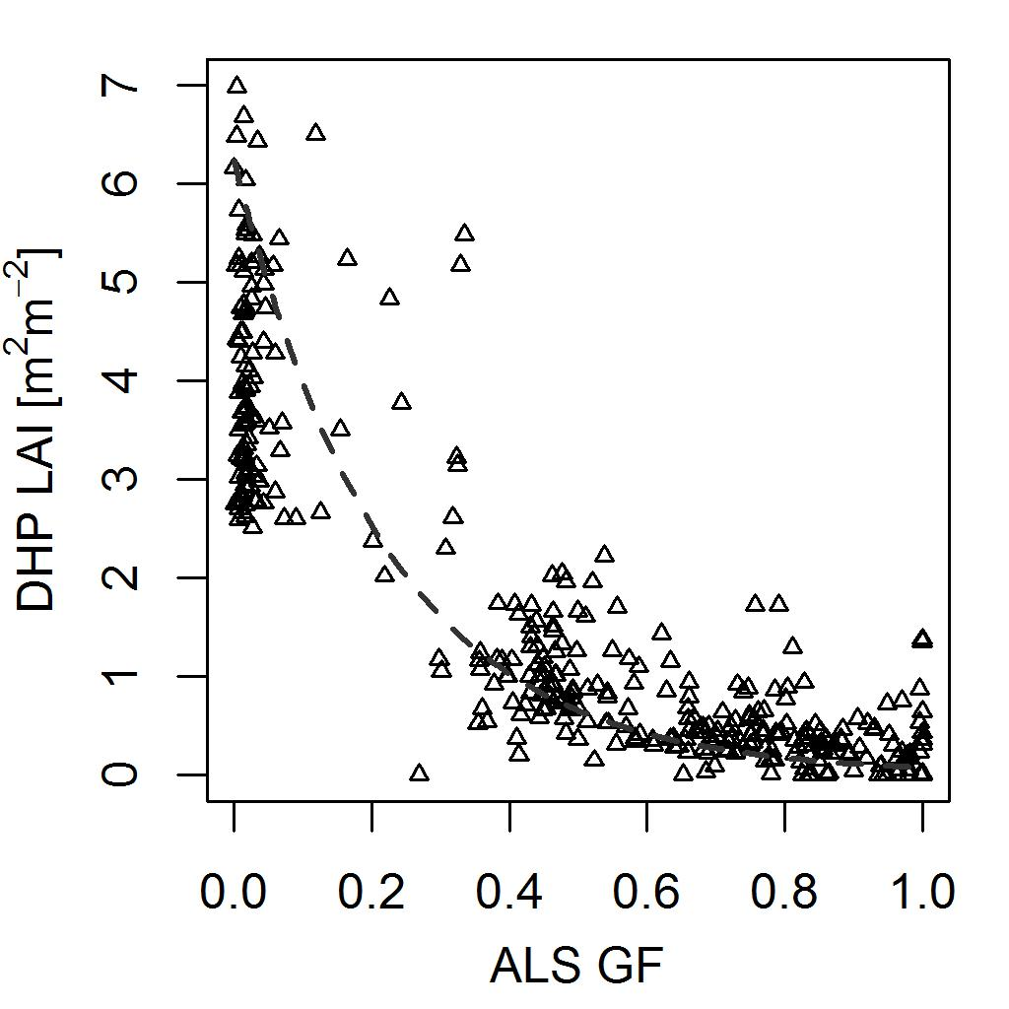

Figure Relationship established between DHP derived LAI and ALS derived GF.

## Country-Wide LAI and LAI Uncertainty

Australia-wide maps of LAI and its associated uncertainty (RF standard deviation) are illustrated in Figure 4a and Figure 4b, respectively. Visual inspection indicates lower values of LAI near the interior, whereas coastal and more mountainous regions appear to exhibit greater values of LAI. Note that regions of no data were deemed to exist beyond the scope of this study, external to the forest landscape of Australia.

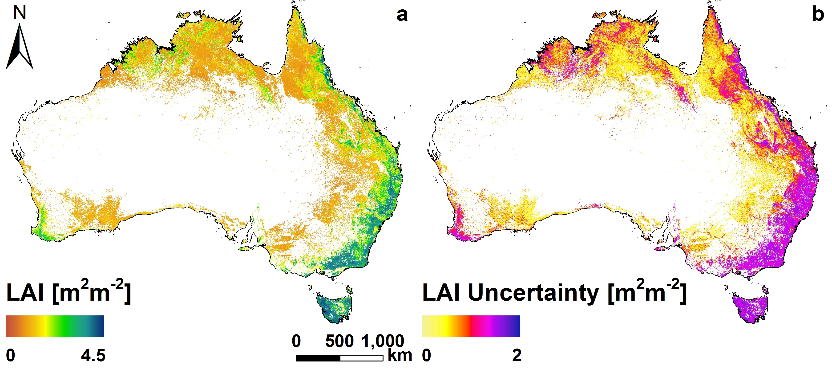

Figure Map of a) LAI, and b) LAI uncertainty as predicted from RF at a 250 m spatial resolution.

## Comparison with ALS

Where ALS data existed, country-wide predictions of LAI were compared directly to ALS equivalents; Figure 5 illustrates the comparisons made across the 20 available ALS sites. The relationship indicates relatively high correspondence between GLAS-based and ALS-based LAI estimates considering the broad range of ecosystem intersection and overall spatial prediction extent; summary statistics for this relationship are noted in Table 4.

Figure 5a indicates that lower values of LAI (≤3) are better predicted than those that are higher, reflecting the distribution of training data used in building the RF model. For ALS-based LAI estimates >4 m2m-2, disparity with GLAS predictions becomes more evident, further indicating the lack of data available for predicting the highest values of LAI via this methodology. Figure 5b illustrates some similarity in the pattern of distributions of ALS and GLAS-based estimates of LAI, indicating that the majority of the ecosystems encountered in this study exhibit low LAI, where few exhibit high values.

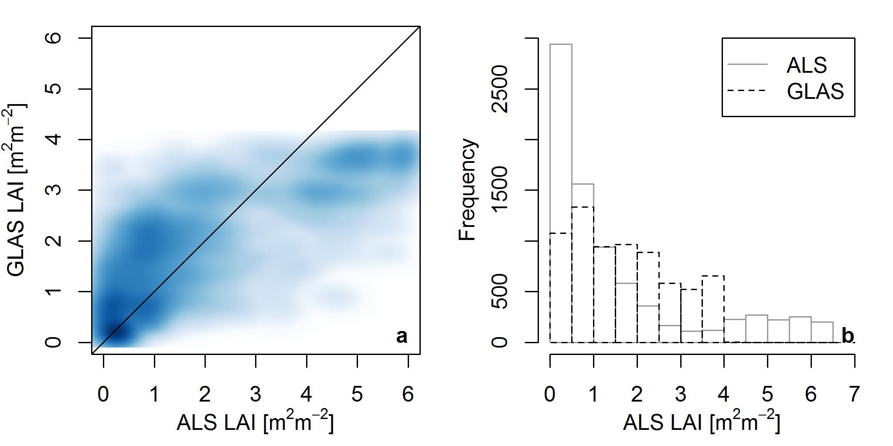

Figure Comparison of RF predicted and ALS derived LAI estimates for 20 sites across Australia indicating: a) density scatter plot (darker blue indicates an increased point density), and b) histogram comparing the ALS (grey) and RF (black dashed) LAI distributions.

## Comparison with MODIS

GLAS-based LAI predictions were compared with a mean composite of MODIS 8-day repeat LAI data between May and October for the years 2004 to 2008. The difference of the MODIS product with respect to the predicted GLAS product is illustrated in Figure 6, where a mean difference of -0.61 m2m-2, and standard deviation of 0.76 m2m-2 is noted. The noted mean is reflected in the most common difference between the 2 products being skewed from zero, between -1 m2m-2 and 0 m2m-2; these occur predominantly in interior regions where savanna type vegetation dominate. Larger differences occur near coastal and mountainous regions; such differences appear less common between the 2 products. However, it is noted that in regions where larger values of LAI are observed (by both methods), GLAS predictions tend to overestimate with respect to MODIS equivalent data, particularly on the east coast (although some relative underestimation is notable also). The most obvious differences between the two products occur on the southwest coast, where GLAS predictions tend to consistently underestimate LAI with respect to MODIS observations.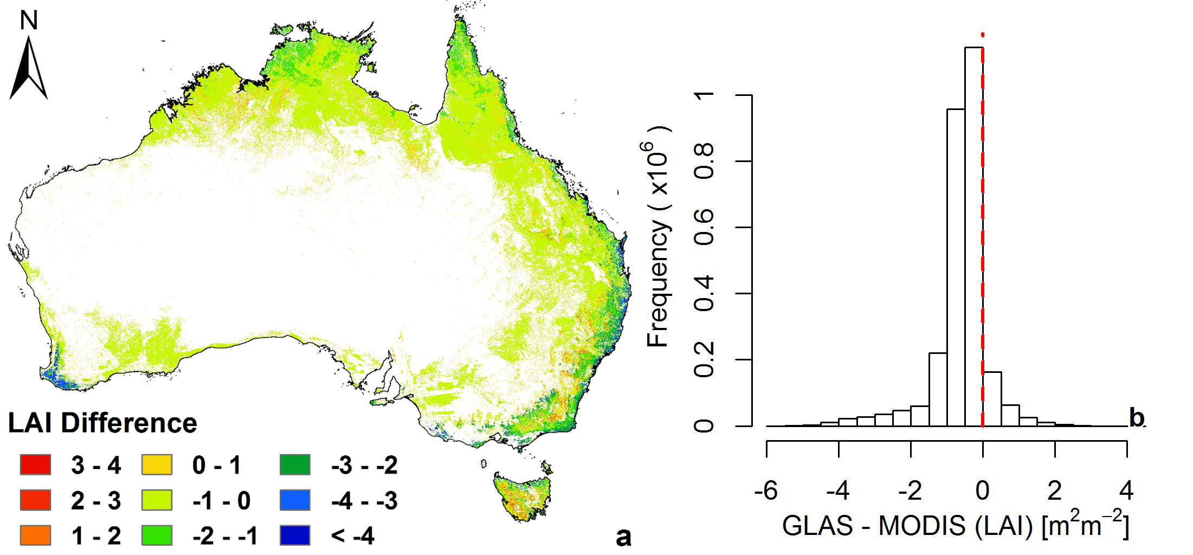

Figure Difference (GLAS minus MODIS) of the predicted LAI product from GLAS and equivalent product from MODIS per 0.5 m2m-2 intervals.

## MODIS Assessment

MODIS-based LAI estimates were directly compared with ALS data across all 20 sites, where LAI information from each site was resampled to 1 km resolution to match that of MODIS. Figure 7a and Figure 7b illustrate a density scatter plot comparison and respective histograms of ALS- and MODIS-based LAI, respectively. In order to demonstrate the capability of the GLAS-based product, a similar comparison with 20 ALS sites is made where the GLAS and ALS data were both resampled to a 1 km resolution. This provides a like-for-like assessment of the quality of MODIS- and GLAS-based estimates of LAI with respect to an independent dataset. Figure 7c and Figure 7d illustrate a density scatter plot comparison and respective histograms of ALS- and GLAS-based LAI, respectively. Corresponding summary statistics for both MODIS and GLAS correspondance with ALS data are noted in Table 4.

MODIS data appear inconsistent with ALS data with the exception of where LAI is observed to be approximately 1 m2m-2; comparatively, no other values of LAI correspond between ALS and MODIS data. Conversely, GLAS-based LAI predictions correspond with ALS equivalents reasonably well, even with the increased pixel size. However, as expected (due to systematic underestimation of extreme values within RF), GLAS-based LAI appear to saturate at approximately 4 m2m-2, whereas MODIS estimates continue to approximately 5.5 m2m-2.

Table Summary statistics for the relationships between ALS and GLAS, and ALS and MODIS at corresponding spatial resolutions.

|  |  |  |  |  |  |
| --- | --- | --- | --- | --- | --- |
| **Comparison** | **N** | **R2** | **RMSE [m2m-2]** | **Fb** | **F2** |
| ALS vs. GLAS [250 m] | 6965 | 0.64 | 1.10 | 0.02 | 0.55 |
| ALS vs. MODIS [1 km] | 517 | 0.30 | 1.78 | 0.34 | 0.38 |
| ALS vs. GLAS [1 km] | 517 | 0.61 | 1.18 | -0.01 | 0.56 |
| N: sample size, Fb: fractional bias, and F2: fraction of predictions within a factor of 2 of observations | | | | | |

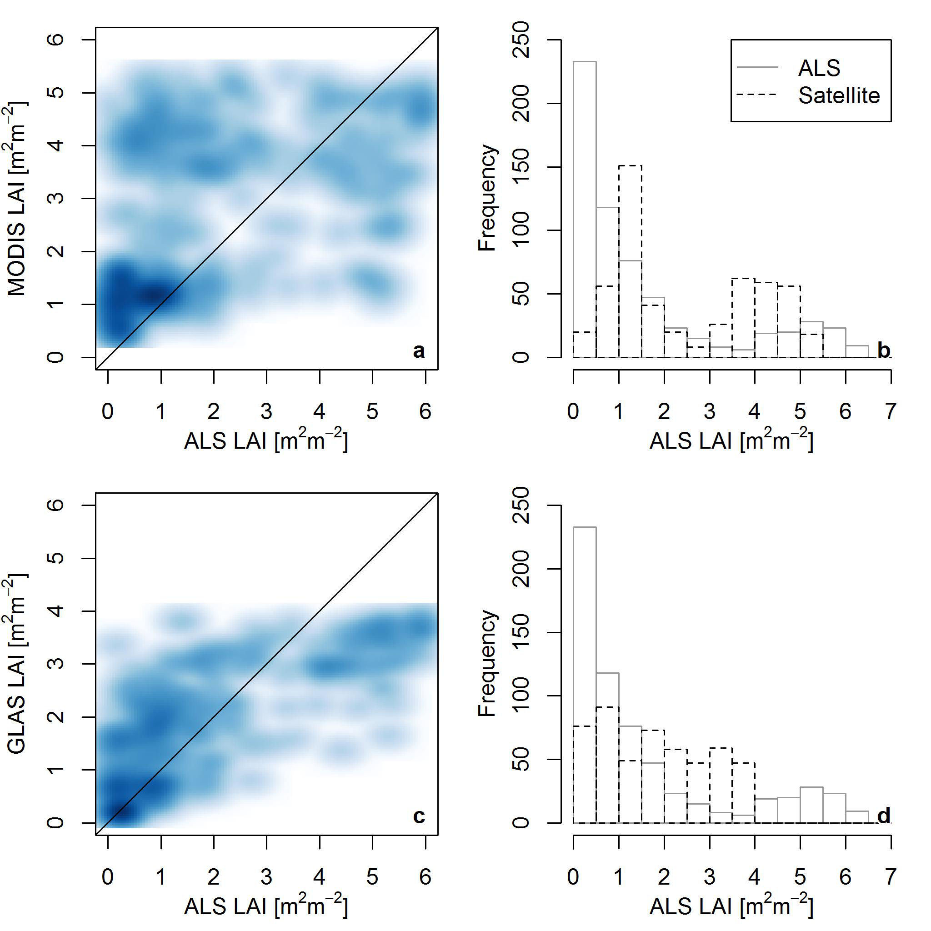

Figure Density scatter comparison of a) MODIS, and c) GLAS derivations of LAI with ALS equivalents for 20 sites across Australia, and histograms comparing ALS (grey) and b) MODIS, and d) GLAS (black dashed) LAI distributions.

## Environmental Influence

The (GLAS) predicted values of LAI were compared with four environmental attributes to investigate the effect of terrain and other vegetation characteristics as a function of LAI across the Australian forest landscape. Figure 8 illustrates predicted values of LAI as a function of elevation, slope, land cover classification, and canopy height.

Figure 8a illustrates that LAI increases with elevation to a threshold where a decrease is then observed; Figure 8b indicates that LAI appears to increase as a function of slope. Figure 8c illustrates the expected correspondence with the tree land cover classes of the DLCD, that is, LAI decreases with the expectation of vegetation becoming more sparse (or less dense with respect to canopy). Figure 8d indicates that LAI tends to increase with canopy height, although a seemingly non-trivial relationship, this relationship is unlikely to be applicable globally as shrubs can often exhibit great density with little height. However, this study is not able to assess this possibility in any detail in Australia, as current predictions of LAI were made for forested regions only, not open regions where the presence of shrubs is expected to be more common.

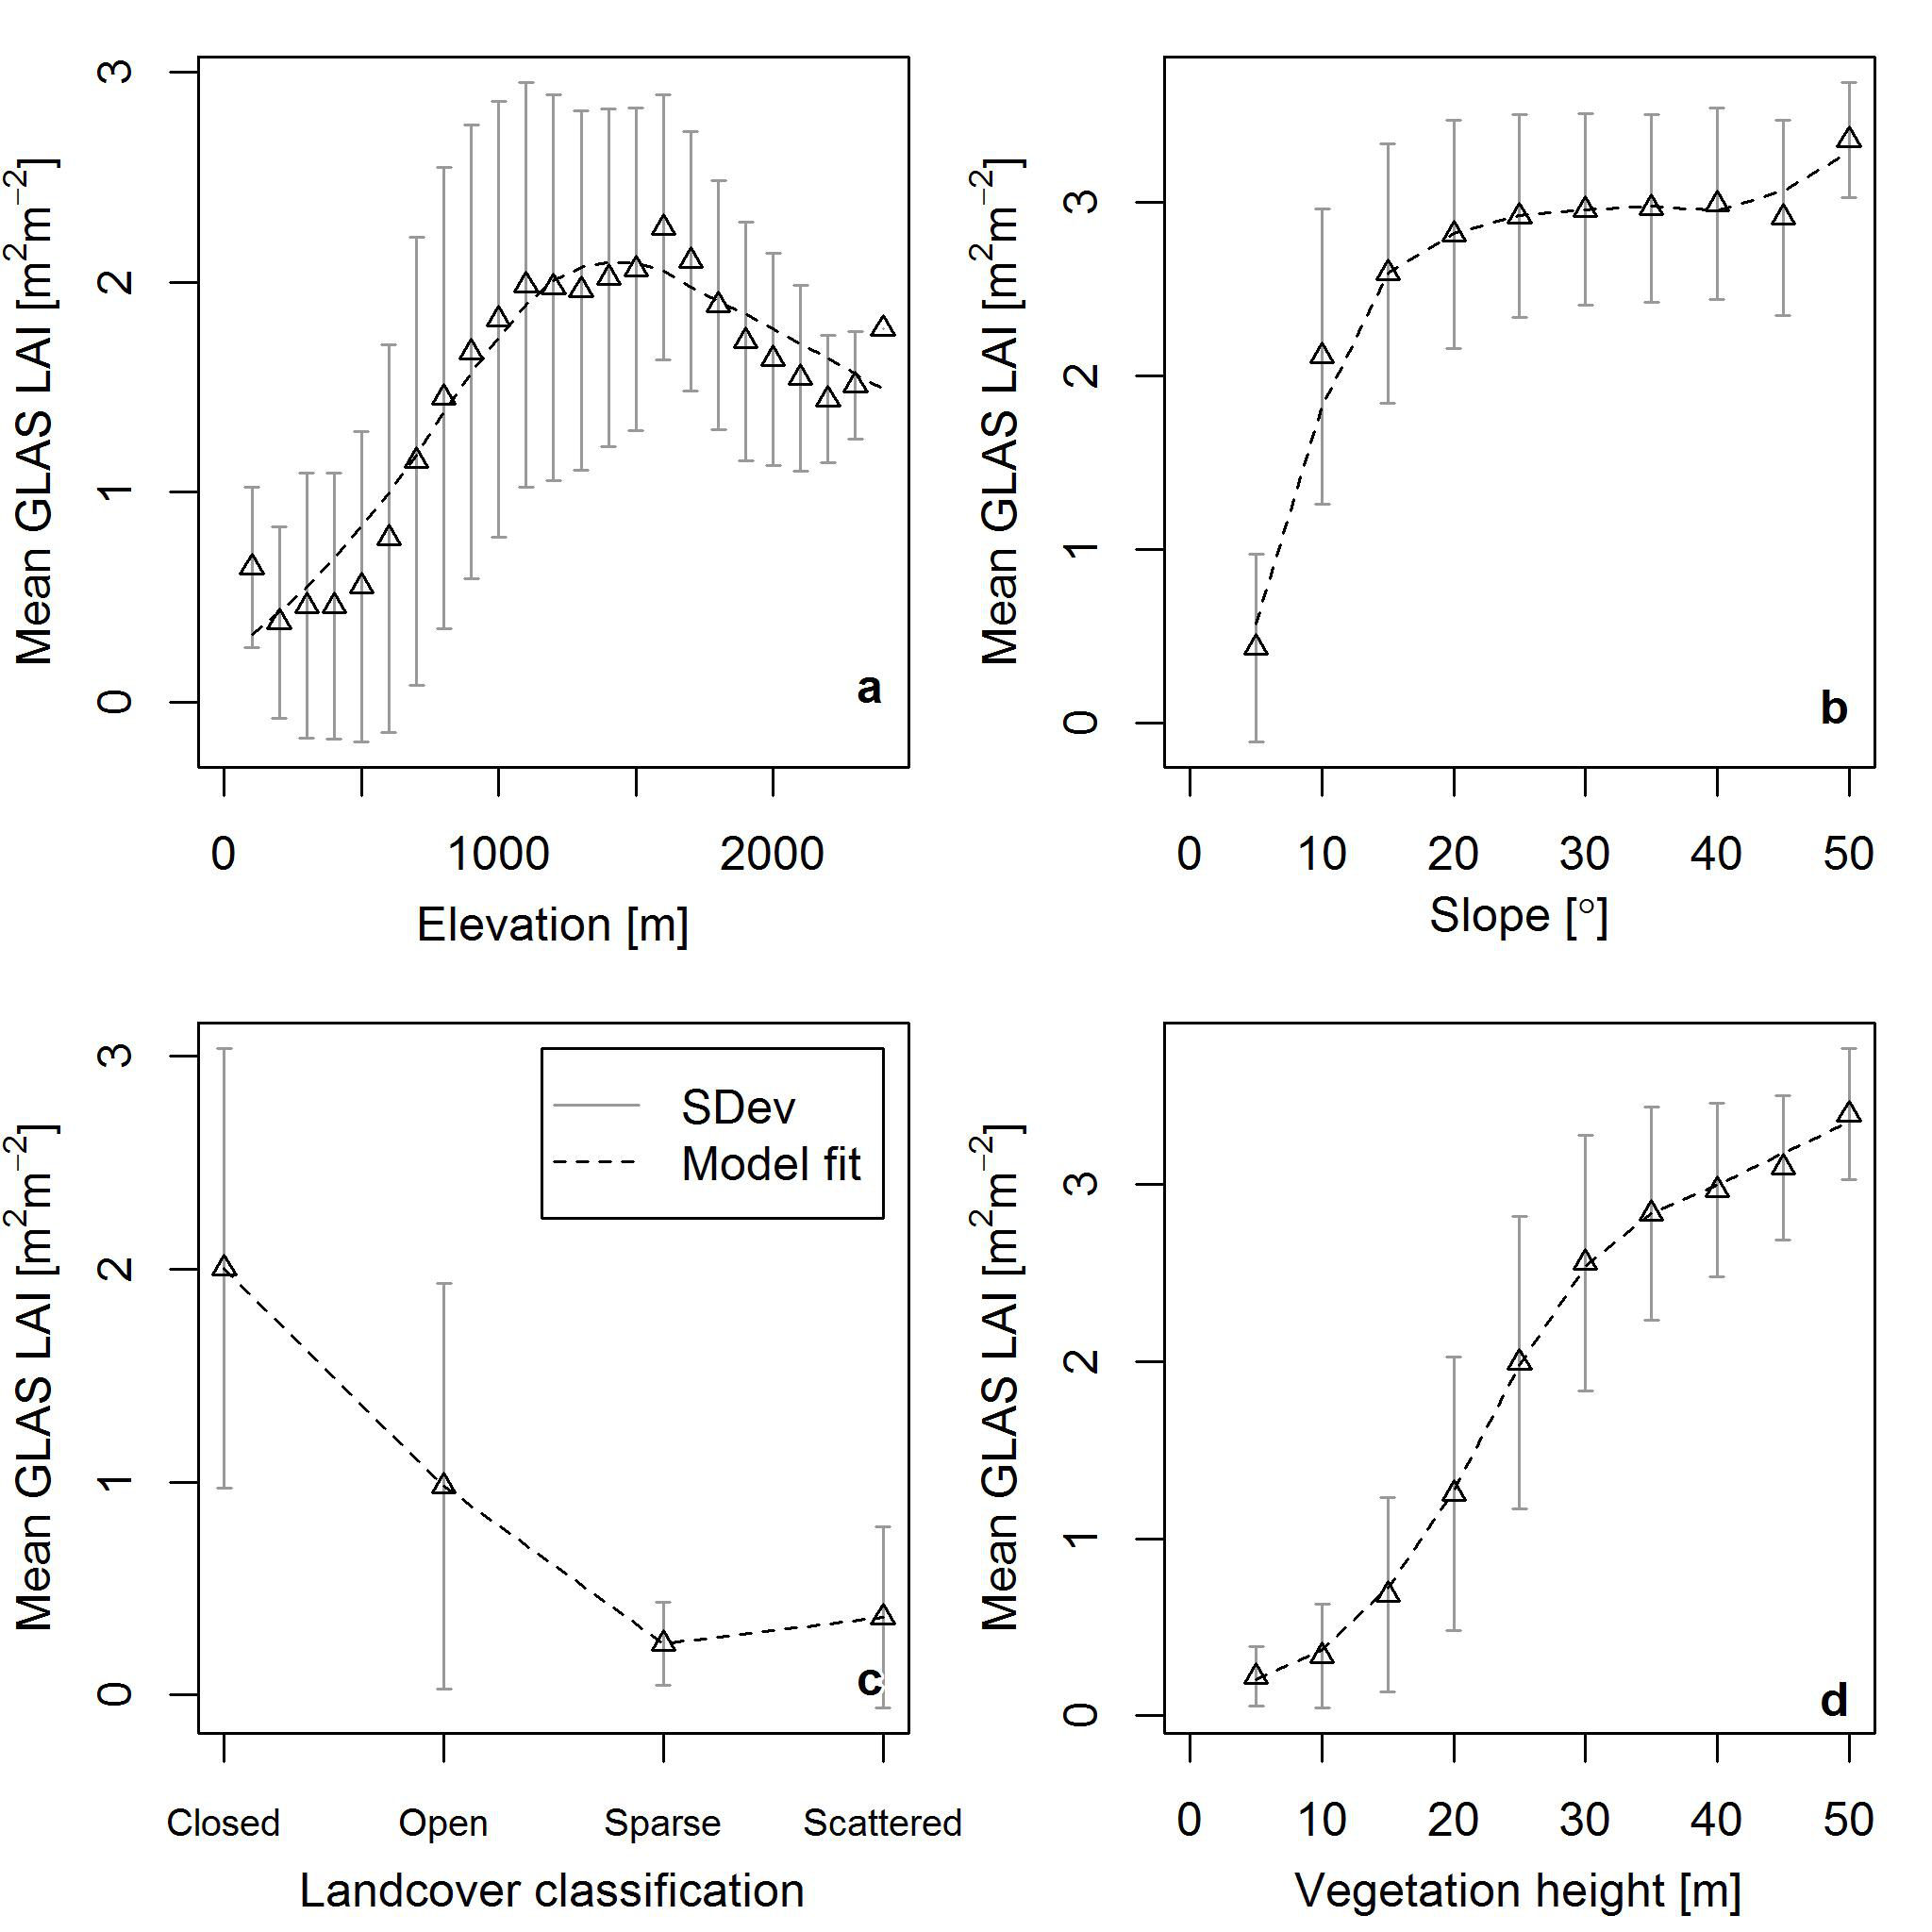

Figure Comparison of predicted LAI estimates with a) elevation, b) slope, c) forest land cover classification, and d) canopy height. Note, ‘model fit’ is the fit of a model to mean values (triangle points) via a local polynomial regression model (loess), and ‘SDev’ illustrates the standard deviation around the mean.

# Discussion

LAI is a key input parameter in ecological models that can help describe the relationship and fluxes of mass and energy between ground, canopy, and atmosphere. Large-scale estimates of vegetation structure parameters, such as LAI, are key elements in the large-scale prediction of such fluxes. The model development of country-wide LAI is reliant on the relationship between DHP-derived LAI and ALS-, and GLAS-derived GF, the later of which has been shown to be highly correlated with ALS GF (post-waveform refinement; Mahoney et al. (2017)). This methodology is rooted in the use of active sensors (airborne and spaceborne) to independently model LAI without the need for prior knowledge, unique from other studies (Luo et al. 2013, Tang et al. 2014).

The current method applied to GLAS data provides a semi-generalised approach to deriving LAI at large (country-wide) scales. Such an approach can be employed at other global locations (and spatial scales) provided suitably acquired field and/or ALS data are available for a reasonable ecosystem cross-section, and sufficient predictor data layers are available. This nested style of approach will likely become increasingly popular given the reduced restrictions on such data by government funded entities across the globe such as TERN and NEON (National Ecological Observatory Network, USA). It is by the provision of data by entities such as these (exclusively TERN in this case) that the current study was able to evaluate products by a wealth of validation and comparison data; this allowed the assessment of the place of the predicted product in the landscape of currently available LAI products.

The comparison of GLAS predicted LAI to 20 sites of ALS data indicates that te majority of ecosystems appear well represented up to those that exhibit >4 m2m-2 LAI. The saturation observed in predictions here are likely rooted in the well documented limitations related to predicting extreme values (i.e. those not frequently encountered in the employed response data). This issue is observed in both the 250 m and 1 km resolution product, presence in the latter is expected as pixels are resampled from the former product.

It is acknowledged that the relative (to MODIS) good performance of country-wide GLAS-based LAI predictions with respect to ALS observations may appear to be due to site tuning. However, the GLAS data employed as the RF response variable, the basis from which the country-wide predictions of LAI were sourced, are independent of ALS and DHP data with the exception of the data from Robson Creek, only. That is, given all 20 ALS sites are used for validation purposes the only potential source of site tuning is from Robson Creek, which represents a small portion of the validation dataset. Furthermore, Robson Creek does not represent a cross section of Australian ecosystems but only semi-tropical rainforests, therefore, if site tuning were prominent it would be expected that only sub-tropical rainforests would be well represented by country-wide predictions. Further solidifying the country-wide product’s independence is that no empirical model between ALS and GLAS GF (used to calculate LAI) was developed due to the unavailability of coincident DHP, ALS, and GLAS data at all sites (excluding Robson Creek). In reaction to this lack of data coincidence, GLAS data were assumed to represent ALS GF for all sites based on the previous findings of Mahoney et al. (2017), who developed a method for scaling GLAS estimates of GF to match ALS equivalents based on four Australian sites, only: Robson Creek, Tumbarumba (strip), Warra, and Watts Creek.

The relatively poor performance of MODIS LAI estimates with respect to ALS observations may be founded in the differences in observations method between the two sensors. MODIS being a passive sensor is incapable of penetrating the canopy to retrieve structural information, where ALS data do exhibit this capability. As a result, it is not surprising that GLAS (an active laser altimeter) performs superior than a passive sensor when compared to results modelled from another active system (ALS). By this reasoning disparity between products is likely rooted in passive and active sensors making fundamentally different measurements, i.e. the former making measurements representative mostly of upper canopy areas, and the latter of the full canopy profile. It is also noted that GLAS values of LAI were calculated from a model developed to relate ALS GF and DHP derived LAI, which does not explain the relative performance of GLAS to ALS, with respect to MODIS.

The relationships with environmental characteristics via the third comparison set provides some insight into the behaviour of LAI within the forest landscape of Australia. Of particular interest is the relationship of LAI with elevation. It is commonly expected that vegetation becomes more sparse and stunted in growth with increased elevation due to the climatic, and often species specific restrictions associated with tree line. However, this study suggests that mean LAI increases with elevation to a point and then decreases as expected; the final two points in the relationsip suggest a secondary increase but these points were derived from very few measurements and are unlikely to be statistically significant. The observed trend likely illustrates the transition between the semi-arid shrub-lands more common at lower elevations, a water limited environment, and the slopes and high meadows of the Australian Alps, a less water limited enviornment. The point at which LAI starts to decrease is likely associated with the thermo-climatic limitation of altitudinal tree line. Beyond this elevation lower mean annual temperatures shorten the growing season and foliage elements do not grow as dense as at lower elevations where the growing season is longer (Körner 1998, Grace et al. 2002, Harsch et al. 2009).

Similarly to elevation, LAI increases with slope; this is believed to be a function of LAI occurring at higher (mountainous) elevations. That is, as vegetation becomes less water limited with elevation and LAI increases, slope is at least partially auto-correlated with elevation also (given the expectation of complex mountainous terrain). The true contribution of slope to LAI is expected to be relatively small as there is little variability between standard deviation values of LAI at each slope interval, suggesting that the illustrated relationship with slope is somewhat random. However, high slope can elongate the wavefrom ground return, which can lead to incorrect atribution of the perceived ground location (Mahoney et al. 2014) which may propagate as spurious LAI values. The relationship with land cover classification is somewhat trivial and illustrates the landscape evolution from the Australian interior where sparse and scattered land cover dominates, and coastal regions where more complex terrain open and closed forest land cover dominates.

The relationship between LAI and canopy height is somewhat expected within Australia, although, it isn’t uncommon to experience dense shrub lands and more sparse mature forests in other regions across the globe. The greatest variability in LAI appears to occur were canopies are between 15 m and 30 m tall, as indicated by the steep gradient and large standard deviation values noted between these canopy heights.

The produced country-wide uncertainties provide an index of RF model convergence on a single value of LAI. Pixels where uncertainty is high relate to a range of conditions (i.e. predictors) that are not well described by the model; the converse is also true. Such information can also be related to the distribution of response data at the RF input stage to indicate which regions require a better description within the model; i.e. what values of LAI and predictor combinations need better representation in the model to better describe particular ecosystems. Providing additional information (by planning future data acquisitions accordingly) in such regions may increase model convergence, providing an overall more accurate model.

It is noteworthy that a number of spatial imputation algorithms exist and have been demonstrated in the work of others (Nelson et al. 2009, Nelson et al. 2009, Lefsky 2010, Los et al. 2012, Beaudoin et al. 2014, Margolis et al. 2015). However, the selection of RF for spatial imputation was strategic as the current study did not attempt to identify which predictors were best suited to the derivation of LAI. Rather, RF algorithms were selected based on their demonstrated success (Simard et al. 2011, Mahoney et al. 2016, Mahoney and Hopkinson InPrep) and ability to select which predictors are best suited to the prediction of LAI from those available.

Whilst this study focussed on producing LAI from an optimal GLAS dataset (Mahoney et al. 2016), it may be possible to provide a time-series of GLAS-based derivations originating in unique GLAS laser campaign analysis. However, this would require the derivation of campaign-tuned scaling factor relationships for the refinement of initial GLAS-based estimate of GF. However, it must be noted that any attempts at such a study can only be realised given sufficient DHP, ALS, and GLAS data overlap. If successful, such a study would likely be able to illustrate the seasonal changes of LAI in the vegetated landscape. However, the broader stimulus for pursuing such analysis is rooted in the application to data from future missions such as the GEDI (Global Ecosystem Dynamics Investigation) LiDAR, and ICEsat-2, proposed for launch in 2018, and 2019, respectively.

# Conclusion

The current study utilised in-situ field acquired DHP, airborne laser scanning, and spaceborne GLAS data to develop an independent Australia-wide model of LAI at a 250 m spatial resolution. The current methodology acknowledges the work of Tang et al. (2014), and Luo et al. (2013), who first attempted to develop GLAS-based models of LAI at large-scales. However, unlike these other studies, the current methodology does not require statistical tuning, or prior knowledge from other sensors (Tang et al. 2014), but is widely applicable provided field and/or ALS LAI data are available for model development purposes. Furthermore, the current study uses multiple independent validation datasets against which the developed country-wide LAI model was compared (R2=0.64, RMSE=1.10 m2m-2).

Direct comparisons (at the same 1 km spatial resolution) of MODIS and GLAS LAI products with 20 ALS sites indicated superior performance by the latter (R2=0.30, RMSE=1.78 m2m-2 compared to R2=0.61, RMSE=1.18 m2m-2).The greatest notable difference between the MODIS and GLAS products likely originates in their sensor type differences. That is, MODIS being a passive sensor is unable to sample and represent structural information throughout the canopy profile, whereas the active GLAS sensor can, similarly to ALS; the disimilarities between the MODIS and validation data likely excacerbate differences.

The transferability of the current method makes it appealing given the growing trend of establishing research infrastructure networks, which encourage the sharing and use of mutliple sources of remote sensing data (such as LiDAR), and given the outlook of the Earth observation satellite mission landscape. The anticipated future availability of multiple in-situ field, ALS, and satellite mission (such as ICESat-2 and GEDI) datasets will pioneer large-scale monitoring investigations of key biophyscial parameters, such as LAI, to better understand Earth system linkages, mitigate climate change, and constantly update forest management strategies to potect ecosystems for future generations.

# Acknowledgements

ICESat/GLAS data were obtained from the National Snow and Ice Data Center (NSIDC, http://nsidc.org), and the interpolated SRTM-DEM version 4.1 data were obtained from the Consultative Group for International Agriculture Research - Consortium for Spatial Information (CGIAR-CSI, http://www.cgiar-csi.org). MODIS (MOD44B) Vegetation Continuous Fields (VCF) and (MCD015A) Leaf Area Index/Fraction of photosynthetically active radiation (fpar) data were obtained from the Global Land Cover Facility (<http://www.landcover.org>) and Land Processing Distributed Active Archiving Center (LPDAAC; https://lpdaac.usgs.gov). The National Vegetation Information System (NVIS) data were obtained from the Department of the Environment, Water, Population and Communities (DSEWPaC), Australian Government; NVIS is a collaborative effort of Australia's states and territories. All ALS data, and soils data were obtained through AusCover (http://www.auscover.org.au). AusCover is the remote sensing data products facility of the Terrestrial Ecosystem Research Network (TERN, http://www.tern.org.au). Special thanks to Airborne Research Australia (ARA) and Fugro Spatial Solutions for carrying out the airborne campaigns. Hopkinson acknowledges the Campus Alberta Innovates Program, the Natural Sciences and Engineering Research Council and the Canada Foundation for Innovation for research and infrastructure funding to the ARTeMiS Laboratory at the University of Lethbridge.

# References

Abshire, J. B., X. L. Sun, H. Riris, J. M. Sirota, J. F. McGarry, S. Palm, D. H. Yi and P. Liiva, 2005. Geoscience Laser Altimeter System (GLAS) on the ICESat mission: On-orbit measurement performance. *Geophysical Research Letters*, 32(L21S02), 10.1029/2005gl024028.

ASRIS, 2014. Australian soil resource information system, CSIRO Canberra, Australia. http://www.asris.csiro.au (last date accessed: October 2014,

Beaudoin, A., P. Y. Bernier, L. Guindon, P. Villemaire, X. J. Guo, G. Stinson, T. Bergeron, S. Magnussen and R. J. Hall, 2014. Mapping attributes of Canada’s forests at moderate resolution through kNN and MODIS imagery. *Canadian Journal of Forest Research*, 44(5), 10.1139/cjfr-2013-0401.

Bond, A. R. and D. N. Jones, 2008. Temporal trends in use of fauna-friendly underpasses and overpasses. *Wildlife Research*, 35(2), Doi 10.1071/Wr07027.

Breiman, L., 2001. Random forests. *Machine Learning*, 45(1), 10.1023/A:1010933404324.

Brenner, A., H. Zwally, C. Bentley, B. Csathó, D. Harding, M. Hofton, J. Minster, L. Roberts, J. Saba, R. Thomas and D. Yi. 2003. Geoscience Laser Altimeter System (GLAS) Algorithm Theoretical Basis Document 4.1: Derivation of Range and Range Distributions From Laser Pulse Waveform Analysis for Surface Elevations, Roughness, Slope, and Vegetation Heights. NASA, Goddard Space Flight Center, Greenbelt, MD 20771, USA.

Burrough, P. A., 1986. Principles of geographical information systems for land resources assessment. *Geocarto International*, 1(3), 10.1080/10106048609354060.

Campbell, G. S., 1986. Extinction coefficients for radiation in plant canopies calculated using an ellipsoidal inclination angle distribution. *Agricultural and Forest Meteorology*, 36(4), http://dx.doi.org/10.1016/0168-1923(86)90010-9.

Campbell, G. S., 1990. Derivation of an angle density function for canopies with ellipsoidal leaf angle distributions. *Agricultural and Forest Meteorology*, 49(3), http://dx.doi.org/10.1016/0168-1923(90)90030-A.

Campbell, G. S. and J. M. Norman, 1989. The description and measurement of plant canopy structure. *Plant Canopies: Their Growth, Form and Function*. (G. Russell, B. Marshall and P. G. Jarvis), Cambridge University Press, Cambridge, UK; New York, NY, USA; Melborne, Australia.

Chasmer, L., N. Kljun, A. Barr, A. Black, C. Hopkinson, H. McCaughey and P. Treitz, 2008. Influences of vegetation structure and elevation on CO2 uptake in a mature jack pine forest in Saskatchewan, Canada. *Canadian Journal of Forest Research*, 38(11), 10.1139/X08-121.

Chen, J. M., A. Govind, O. Sonnentag, Y. Zhang, A. Barr and B. Amiro, 2006. Leaf area index measurements at Fluxnet-Canada forest sites. *Agricultural and Forest Meteorology*, 140(1–4), http://dx.doi.org/10.1016/j.agrformet.2006.08.005.

Chen, Q., 2010. Retrieving vegetation height of forests and woodlands over mountainous areas in the Pacific Coast region using satellite laser altimetry. *Remote Sensing of Environment*, 114(7), 10.1016/j.rse.2010.02.016.

DiMiceli, C. M., M. L. Carroll, R. A. Sohlberg, C. Huang, M. C. Hansen and J. R. G. Townshend, 2011. Annual Global Automated MODIS Vegetation Continuous Fields. University of Maryland, Maryland, USA.

Duong, V. H., R. Lindenbergh, N. Pfeifer and G. Vosselman, 2008. Single and two epoch analysis of ICESat full waveform data over forested areas. *International Journal of Remote Sensing*, 29(5), 10.1080/01431160701736372.

ESCAVI. 2003. Australian Vegetation Attribute Manual: National Vegetation Information System. Executive steering committee for australian vegetation information (ESCAVI), Department of Environment and Heritage, Canberra, Australia.

Finlayson, C. and I. von Oertzen, 1996. The Kakadu region. *Landscape and vegetation ecology of the Kakadu Region, northern Australia*. (C. Finlayson and I. von Oertzen), Kluwer Academic Publishers, Dordrecht, The Netherlands.1-16.

Frazer, G. W., J. A. Trofymow and K. P. Lertzman. 1997. A method for estimating canopy openness, effective leaf area index, and photosynthetically active photon flux density using hemispherical photography and computerized image analysis techniques. C. F. S. Natural Resources Canada, Pacific Forestry Centre, Victoria, BC, Canada.

Gallant, J. C. and T. I. Dowling, 2003. A multiresolution index of valley bottom flatness for mapping depositional areas. *Water Resources Research*, 39(12), 10.1029/2002WR001426.

Gallant, J. C., T. I. Dowling, A. M. Read, N. Wilson, P. Tickle and C. Inskeep, 2011. 1 second SRTM Derived Digital Elevation Models User Guide, www.ga.gov.au/scientific-topics/national-location-information/digital-elevation-data (last date accessed: September 2015,

Gonsamo, A., J.-M. N. Walter and P. Pellikka, 2011. CIMES: A package of programs for determining canopy geometry and solar radiation regimes through hemispherical photographs. *Computers and Electronics in Agriculture*, 79(2), http://dx.doi.org/10.1016/j.compag.2011.10.001.

Grace, J., F. Berninger and L. Nagy, 2002. Impacts of Climate Change on the Tree Line. *Annals of Botany*, 90(4), 10.1093/aob/mcf222.

Harding, D. J. and C. C. Carabajal, 2005. ICESat waveform measurements of within-footprint topographic relief and vegetation vertical structure. *Geophysical Research Letters*, 32(L21S10), 10.1029/2005gl023471.

Harsch, M. A., P. E. Hulme, M. S. McGlone and R. P. Duncan, 2009. Are treelines advancing? A global meta-analysis of treeline response to climate warming. *Ecology Letters*, 12(10), 10.1111/j.1461-0248.2009.01355.x.

Hopkinson, C. and L. Chasmer, 2009. Testing LiDAR models of fractional cover across multiple forest ecozones. *Remote Sensing of Environment*, 113(1), 10.1016/j.rse.2008.09.012.

Hopkinson, C., J. Lovell, L. Chasmer, D. Jupp, N. Kljun and E. van Gorsel, 2013. Integrating terrestrial and airborne lidar to calibrate a 3D canopy model of effective leaf area index. *Remote Sensing of Environment*, 136(1), 10.1016/j.rse.2013.05.012.

Huang, L.-K. and M.-J. J. Wang, 1995. Image thresholding by minimizing the measures of fuzziness. *Pattern Recognition*, 28(1), http://dx.doi.org/10.1016/0031-3203(94)E0043-K.

Korhonen, L., I. Korpela, J. Heiskanen and M. Maltamo, 2011. Airborne discrete-return LIDAR data in the estimation of vertical canopy cover, angular canopy closure and leaf area index. *Remote Sensing of Environment*, 115(4), 10.1016/j.rse.2010.12.011.

Körner, C., 1998. A Re-Assessment of High Elevation Treeline Positions and Their Explanation. *Oecologia*, 115(4), 445-459.

Leblanc, S. 2004. Digital Hemispherical Photography Manual. C. C. f. R. S. Natural Resources Canada, Centre Spatial John H. Chapman, Saint-Hubert, Québec, Canada.

Lefsky, M. A., 2010. A global forest canopy height map from the Moderate Resolution Imaging Spectroradiometer and the Geoscience Laser Altimeter System. *Geophysical Research Letters*, 37(L15401), doi: 10.1029/2010gl043622.

Lefsky, M. A., W. B. Cohen, S. A. Acker, G. G. Parker, T. A. Spies and D. Harding, 1999. Lidar remote sensing of the canopy structure and biophysical properties of Douglas-fir western hemlock forests. *Remote Sensing of Environment*, 70(3), Doi 10.1016/S0034-4257(99)00052-8.

Lefsky, M. A., W. B. Cohen, G. G. Parker and D. J. Harding, 2002. Lidar remote sensing for ecosystem studies. *Bioscience*, 52(1), 10.1641/0006-3568(2002)052[0019:Lrsfes]2.0.Co;2.

Los, S. O., J. A. B. Rosette, N. Kljun, P. R. J. North, L. Chasmer, J. C. Suarez, C. Hopkinson, R. A. Hill, E. van Gorsel, C. Mahoney and J. A. J. Berni, 2012. Vegetation height and cover fraction between 60° S and 60° N from ICESat GLAS data. *Geoscientific Model Development*, 5(2), 10.5194/gmd-5-413-2012.

Luo, S. Z., C. Wang, G. C. Li and X. H. Xi, 2013. Retrieving leaf area index using ICESat/GLAS full-waveform data. *Remote Sensing Letters*, 4(8), 10.1080/2150704X.2013.790573.

Lymburner, L., P. Tan, N. Mueller, R. Thackway, A. Lewis, M. Thankappan, L. Randall, A. Islam and U. Senarath. 2011. The National Dynamic Land Cover Dataset. Geoscience Australia, Canberra, Australia.

Macfarlane, C., M. Hoffman, D. Eamus, N. Kerp, S. Higginson, R. McMurtrie and M. Adams, 2007. Estimation of leaf area index in eucalypt forest using digital photography. *Agricultural and Forest Meteorology*, 143(3-4), DOI 10.1016/j.agrformet.2006.10.013.

Mahoney, C. and C. Hopkinson, 2017. Continental Estimates of Canopy Gap Fraction by Active Remote Sensing. *Canadian Journal of Remote Sensing*, 43(4), 10.1080/07038992.2017.1346469.

Mahoney, C. and C. Hopkinson, InPrep. Country-wide estimates of canopy gap fraction by active remote sensing. *Canadian Journal of Remote Sensing*, X(Y), xx-yy.

Mahoney, C., C. Hopkinson, A. Held and M. Simard, 2016. Continental-Scale Canopy Height Modeling by Integrating National, Spaceborne, and Airborne LiDAR Data. *Canadian Journal of Remote Sensing*, 10.1080/07038992.2016.1196580.

Mahoney, C., C. Hopkinson, N. Kljun and E. Van Gorsel, 2016. ICESat/GLAS canopy height sensitivity inferred from airborne LiDAR. *Photogrammetric Engineering and Remote Sensing*, 82(5), 351-363.

Mahoney, C., C. Hopkinson, N. Kljun and E. Van Gorsel, 2017. Estimating Canopy Gap Fraction Using ICESat GLAS within Australian Forest Ecosystems. *Remote Sensing*, 9(59), 10.3390/rs9010059.

Mahoney, C., N. Kljun, S. O. Los, L. Chasmer, J. M. Hacker, C. Hopkinson, P. R. J. North, J. A. B. Rosette and E. van Gorsel, 2014. Slope Estimation from ICESat/GLAS. *Remote Sensing*, 6(10), 10.3390/Rs61010051.

Margolis, H. A., R. F. Nelson, P. M. Montesano, A. Beaudoin, G. Sun, H.-E. Andersen and M. A. Wulder, 2015. Combining satellite lidar, airborne lidar, and ground plots to estimate the amount and distribution of aboveground biomass in the boreal forest of North America. *Canadian Journal of Forest Research*, 45(7), 10.1139/cjfr-2015-0006.

Means, J. E., S. A. Acker, D. J. Harding, J. B. Blair, M. A. Lefsky, W. B. Cohen, M. E. Harmon and W. A. McKee, 1999. Use of large-footprint scanning airborne lidar to estimate forest stand characteristics in the Western Cascades of Oregon. *Remote Sensing of Environment*, 67(3), 10.1016/S0034-4257(98)00091-1.

Meyer, W., E. Kondrlova and G. Koerber, 2015. Evaporation of perennial semi-arid woodland in southeastern Australia is adapted for irregular but common dry periods. *Hydrological Processes*, 29(17), 3714-3726.

Nelson, R., J. Boudreau, T. G. Gregoire, H. Margolis, E. Næsset, T. Gobakken and G. Ståhl, 2009. Estimating Quebec provincial forest resources using ICESat/GLAS. *Canadian Journal of Forest Research*, 39(4), 10.1139/X09-002.

Nelson, R., K. J. Ranson, G. Sun, D. S. Kimes, V. Kharuk and P. Montesano, 2009. Estimating Siberian timber volume using MODIS and ICESat/GLAS. *Remote Sensing of Environment*, 113(3), 10.1016/j.rse.2008.11.010.

OzFlux, 2014. Australian and New Zealand Flux research and Monitoring: Robson Creek Site Information, http://www.ozfux.org.au/monitoringsites/cumberlandplains/index.html (last date accessed: November 2014,

Prewitt, J. M. S. and M. L. Mendelsohn, 1966. The Analysis of Cell Images. *Annals of the New York Academy of Sciences*, 128(3), 10.1111/j.1749-6632.1965.tb11715.x.

Richardson, A. D., R. S. Anderson, M. A. Arain, A. G. Barr, G. Bohrer, G. Chen, J. M. Chen, P. Ciais, K. J. Davis, A. R. Desai, M. C. Dietze, D. Dragoni, S. R. Garrity, C. M. Gough, R. Grant, D. Y. Hollinger, H. A. Margolis, H. McCaughey, M. Migliavacca, R. K. Monson, J. W. Munger, B. Poulter, B. M. Raczka, D. M. Ricciuto, A. K. Sahoo, K. Schaefer, H. Tian, R. Vargas, H. Verbeeck, J. Xiao and Y. Xue, 2012. Terrestrial biosphere models need better representation of vegetation phenology: results from the North American Carbon Program Site Synthesis. *Global Change Biology*, 18(2), 10.1111/j.1365-2486.2011.02562.x.

Richardson, J. J., L. M. Moskal and S.-H. Kim, 2009. Modeling approaches to estimate effective leaf area index from aerial discrete-return LIDAR. *Agricultural and Forest Meteorology*, 149(6–7), http://dx.doi.org/10.1016/j.agrformet.2009.02.007.

Ridler, T. W. and S. Calvard, 1978. Picture Thresholding Using an Iterative Selection Method. *IEEE Transactions on Systems, Man, and Cybernetics*, 8(8), 10.1109/TSMC.1978.4310039.

Rosette, J., P. R. J. North, J. Rubio-Gil, B. Cook, S. Los, J. Suarez, G. Q. Sun, J. Ranson and J. B. Blair, 2013. Evaluating Prospects for Improved Forest Parameter Retrieval From Satellite LiDAR Using a Physically-Based Radiative Transfer Model. *IEEE Journal of Selected Topics in Applied Earth Observations and Remote Sensing*, 6(1), 10.1109/Jstars.2013.2244199.

Rosette, J. A. B., P. R. J. North and J. C. Suarez, 2008. Vegetation height estimates for a mixed temperate forest using satellite laser altimetry. *International Journal of Remote Sensing*, 29(5), 10.1080/01431160701736380.

Rosette, J. A. B., P. R. J. North, J. C. Suarez and S. O. Los, 2010. Uncertainty within satellite LiDAR estimations of vegetation and topography. *International Journal of Remote Sensing*, 31(5), Doi 10.1080/01431160903380631.

Rossel, R. A. V., C. Chen, M. J. Grundy, R. Searle, D. Clifford and P. H. Campbell, 2015. The Australian three-dimensional soil grid: Australia’s contribution to the GlobalSoilMap project. *Soil Research*, dx.doi.org/10.1071/SR14366.

Ryu, Y., J. Verfaillie, C. Macfarlane, H. Kobayashi, O. Sonnentag, R. Vargas, S. Ma and D. D. Baldocchi, 2012. Continuous observation of tree leaf area index at ecosystem scale using upward-pointing digital cameras. *Remote Sensing of Environment*, 126(http://dx.doi.org/10.1016/j.rse.2012.08.027.

Schneider, C. A., W. S. Rasband and K. W. Eliceiri, 2012. NIH Image to ImageJ: 25 years of image analysis. *Nat Meth*, 9(7), 671-675.

Schutz, B. E., H. J. Zwally, C. A. Shuman, D. Hancock and J. P. DiMarzio, 2005. Overview of the ICESat Mission. *Geophysical Research Letters*, 32(L21S01), 10.1029/2005gl024009.

Simard, M., N. Pinto, J. B. Fisher and A. Baccini, 2011. Mapping forest canopy height globally with spaceborne lidar. *Journal of Geophysical Research-Biogeosciences*, 116(G04021), 10.1029/2011jg001708.

Tang, H., M. Brolly, F. Zhao, A. H. Strahler, C. L. Schaaf, S. Ganguly, G. Zhang and R. Dubayah, 2014. Deriving and validating Leaf Area Index (LAI) at multiple spatial scales through lidar remote sensing: A case study in Sierra National Forest, CA. *Remote Sensing of Environment*, 143(10.1016/j.rse.2013.12.007.

Tang, H., R. Dubayah, M. Brolly, S. Ganguly and G. Zhang, 2014. Large-scale retrieval of leaf area index and vertical foliage profile from the spaceborne waveform lidar (GLAS/ICESat). *Remote Sensing of Environment*, 154(10.1016/j.rse.2014.08.007.

Tang, H., R. Dubayah, A. Swatantran, M. Hofton, S. Sheldon, D. B. Clark and B. Blair, 2012. Retrieval of vertical LAI profiles over tropical rain forests using waveform lidar at La Selva, Costa Rica. *Remote Sensing of Environment*, 124(10.1016/j.rse.2012.05.005.

TERN, 2013. From tall trees to high country, Terrestrial Ecosystem Research Network (TERN) infrastructure measures, Victoria. http://mymail.ezemsgs.com/em/message/email/view.php?id=1033534&u=45618 (last date accessed: October 2014,

Thomas, S. C. and W. E. Winner, 2000. Leaf area index of an old-growth Douglas-fir forest estimated from direct structural measurements in the canopy. *Canadian Journal of Forest Research*, 30(1), 1922-1930.

Traver, E., B. E. Ewers, D. S. Mackay and M. M. Loranty, 2010. Tree transpiration varies spatially in response to atmospheric but not edaphic conditions. *Functional Ecology*, 24(2), 10.1111/j.1365-2435.2009.01657.x.

Trevithick, B., 2015. Hemispheric Photography Protocol., AusCover Remote Sensing Data Facility. http://www.auscover.org.au/xwiki/bin/view/Field+Sites/Hemispheric_Protocol (last date accessed: March 2016,

Tsai, W.-H., 1985. Moment-preserving thresolding: A new approach. *Computer Vision, Graphics, and Image Processing*, 29(3), http://dx.doi.org/10.1016/0734-189X(85)90133-1.

van Gorsel, E., R. Leuning, H. A. Cleugh, H. Keith, M. U. F. Kirschbaum and T. Suni, 2008. Application of an alternative method to derive reliable estimates of nighttime respiration from eddy covariance measurements in moderately complex topography. *agricultural and forest meteorology*, 148(6), 10.1016/j.agrformet.2008.01.015.

Watson, A., S. Judd, J. Watson, A. Lam and D. Mackenzie. 2008. The extraordinary nature of the Great Western Woodlands. Wilderness Society of Western Australia, Perth, Australia.

Watson, D. J., 1947. Comparative physiological studies on the growth of field crops: I. variation in net assimilation rate and leaf area between species and varieties, and within and between years. *Annals of Botany*, 11(1), 41-76.

Welles, J. M. and J. M. Norman, 1991. Instrument for Indirect Measurement of Canopy Architecture. *Agronomy Journal*, 83(5), 10.2134/agronj1991.00021962008300050009x.

Wilson, K. B., P. J. Hanson, P. J. Mulholland, D. D. Baldocchi and S. D. Wullschleger, 2001. A comparison of methods for determining forest evapotranspiration and its components: sap-flow, soil water budget, eddy covariance and catchment water balance. *Agricultural and Forest Meteorology*, 106(2), http://dx.doi.org/10.1016/S0168-1923(00)00199-4.

Zhao, L., J. Xia, C.-y. Xu, Z. Wang, L. Sobkowiak and C. Long, 2013. Evapotranspiration estimation methods in hydrological models. *Journal of Geographical Sciences*, 23(2), 10.1007/s11442-013-1015-9.

Zwally, H., B. Schutz, C. Bentley, J. Bufton, T. Herring, J. Minster, J. Spinhirne and R. Thomas, 2011. GLAS/ICESat L2 Global Land Surface Altimetry Data, Version 33. National Snow and Ice Data Center (NSIDC), Boulder, CO, USA.